SHUBHAYAN BARAL
30/12/2025
Exploring the Factors Affecting Employee Attrition

Attrition Analytics – Exploratory Analysis & Predictive Modelling
Problem Statement
Human resources are among the most critical assets of any organization. Companies invest substantial time and cost in recruiting, training, and developing employees. Employee attrition leads to increased recruitment costs, loss of skilled talent, reduced productivity, and disruption in business continuity.
Attrition can occur due to multiple factors such as dissatisfaction with salary, lack of career growth opportunities, poor work-life balance, excessive workload, limited recognition, and organizational policies. When attrition rates rise, it negatively impacts both operational efficiency and organizational morale.
If Human Resource departments can predict employees who are at risk of leaving, they can take proactive measures such as targeted retention strategies or preventive hiring to minimize business impact.

Objective
The objective of this project is to:
- Analyze key factors influencing employee attrition
- Identify patterns and drivers responsible for attrition
- Build predictive machine learning models to classify employees who are likely to leave the organization
- Provide actionable insights and recommendations to reduce attrition

Hypotheses
- Employee attrition increases recruitment, training, and operational costs.
- Attrition negatively impacts productivity and long-term profitability.
- Factors such as income, overtime, job satisfaction, work-life balance, and experience influence attrition.

Dataset Description
The dataset used in this analysis is the IBM HR Analytics Employee Attrition dataset, which contains information about 1470 employees.
- Target Variable: Attrition
  - 1 → Employee left the organization
  - 0 → Employee stayed
- Numerical Features:
Age, Monthly Income, Total Working Years, Years at Company, Distance from Home
- Categorical Features:
Job Role, Department, Business Travel, OverTime, Job Satisfaction, Work-Life Balance, Education Field
The dataset is imbalanced, with a significantly higher number of employees staying compared to those leaving.

Exploratory Data Analysis (EDA)
Attrition Distribution
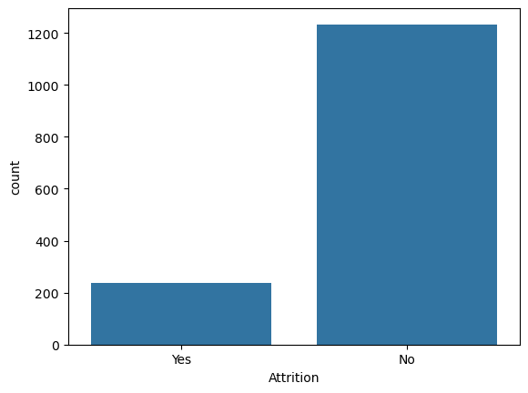
Observation: Majority of employees did not leave the company.
Job Role vs Attrition
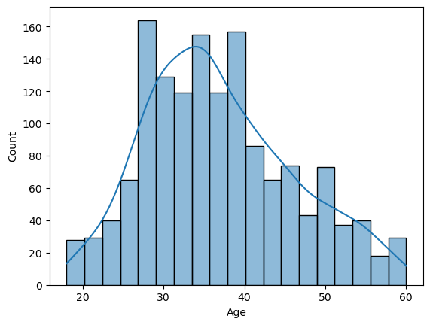
Observation:
- Younger employees exhibit higher attrition rates.
- Majority of people who left the company are below 40 and among the people who didn't left the company are of age 32 to 40 years.
- Attrition decreases with increasing age and experience.
Insight: Early-career employees are more likely to leave.

Monthly Income vs Attrition
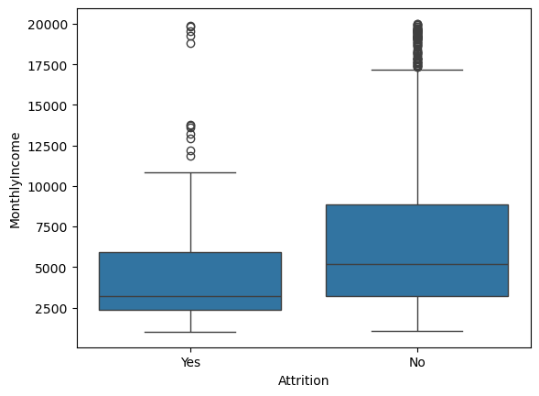
Observation:
- Employees with lower monthly income exhibit higher attrition.
- Higher income brackets show improved retention.
Insight: Compensation plays a crucial role in employee retention.

Overtime vs Attrition
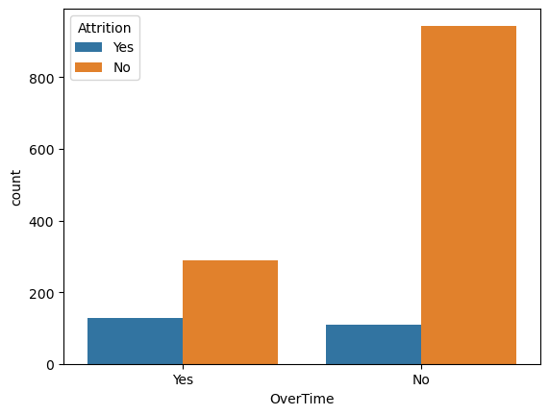
Observations:
- Employees working overtime show significantly higher attrition.
- More than 30% of employee's who worked overtime has left the company, where as 90% of employee's who have not experienced overtime has not left the company.
- Employees without overtime demonstrate better retention.
Insight: Workload and work-life balance are strong drivers of attrition.

Jobrole vs Attrition
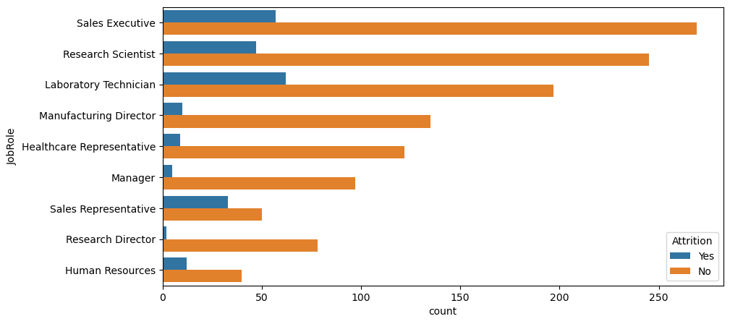
Observations:
- Sales Executive has the highest number of attrition cases among all job roles.
- Laboratory Technician and Research Scientist also show noticeable attrition, though lower than sales roles.
- Sales Representative shows a high attrition ratio relative to its size, even though the total count is smaller.
- Manager and Manufacturing Director roles have very low attrition counts.
- Research Director shows almost no attrition, indicating strong role stability.
Insight:
Sales-oriented and frontline roles are more prone to attrition, while senior and leadership roles demonstrate higher stability.

Travel vs Attrition
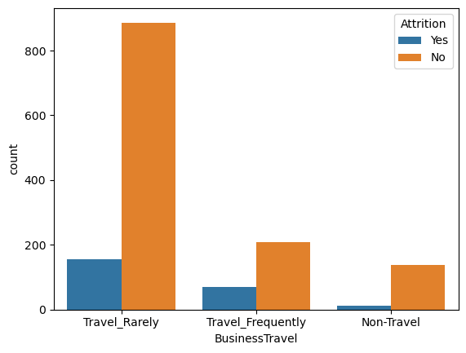
Observations:
- Employees who Travel Rarely show the highest absolute attrition count because they represent the largest employee group.
- Employees who Travel Frequently show a higher attrition proportion, indicating higher risk.
- Non Travel employees have the lowest attrition, showing better retention.
Insight:
Increased business travel is associated with higher attrition risk due to stress and work-life imbalance.

Predictive Modelling
Two machine learning models were developed and evaluated.
Decision Tree Classifier
Results:
- Accuracy: 77.78%
Confusion Matrix:
[[324 56]
[ 42 19]]
Interpretation:
- Performs well for predicting employees who stay.
- Poor recall (31%) for employees who leave.
- Accuracy is misleading due to class imbalance.

Random Forest Classifier
Results:
- Accuracy: 84.81%
Confusion Matrix:
[[353 27]
[ 40 21]]
Interpretation:
- Improved overall accuracy and generalization.
- Better precision and recall for attrition cases.
- Reduced false positives compared to Decision Tree.
Model Comparison Summary
Metric | Decision Tree | Random Forest
Accuracy | 77.8% | 84.8%
Attrition Precision | 0.25 | 0.44
Attrition Recall | 0.31 | 0.34
Attrition F1-score | 0.28 | 0.39
Final Model Selected: Random Forest Classifier

Business Interpretation
- Accuracy alone is insufficient for imbalanced HR datasets.
- Recall and precision for attrition are more meaningful metrics.
- Random Forest provides a better balance between identifying at-risk employees and minimizing false alarms.
- Sales roles combined with frequent travel and overtime represent the highest attrition risk.

Key Business Insights
- Sales-related job roles experience the highest attrition.
- Frequent business travel increases attrition probability.
- Overtime strongly correlates with employee turnover.
- Lower income and early-career stage contribute to attrition.
- Leadership and senior roles show strong retention.

Recommendations
- Reduce excessive overtime and workload pressure.
- Re-evaluate compensation structures for lower-income roles.
- Introduce targeted retention programs for sales teams.
- Optimize business travel policies and offer flexibility.
- Focus on early-career employee engagement and growth plans.

Conclusion
This project successfully analyzed employee attrition using exploratory data analysis and machine learning techniques. By comparing Decision Tree and Random Forest models, the Random Forest classifier was identified as the superior model due to its improved accuracy and better identification of attrition cases. The insights and recommendations from this analysis can help HR departments proactively reduce attrition and improve employee retention strategies.

